New RiLineX versions up to 550 A
Power distribution: save 50 per cent copper with new complete boards
Herborn, 31 March 2025.
Last year, Rittal introduced a new industry standard for power distribution with its RiLineX platform system. Now, at Hannover Messe, new complete boards from the RiLineX platform, designed for low currents of up to 550 A, are being launched. Copper bars with a smaller cross-section reduce raw material usage and costs in numerous applications, for example in mechanical engineering.
The RiLineX “Click & Work” system enables the of safe power distribution systems to be set up rapidly, providing time savings of up to 30% in planning and designing and as much as 75% in assembly. Standardisation is combined with a high level of flexibility through the platform system and the combination of complete boards and modular systems. This concept is now being expanded at the sales launch. At Hannover Messe, the company is introducing new, fully assembled boards to the system, which enable a rated current of up to 550 A and a short-circuit resistance of up to 52.5 kA, at the same time using less copper. For the recently presented options up to 800 A, Rittal now guarantees a short-circuit strength of up to 65 kA. Every complete board is available in the standard enclosure widths of 600 mm, 800 mm, 1,000 mm, and 1,200 mm, and can be configured in a flash.

“We began with boards of up to 800 A plus a fully flexible modular system to provide a wide variety of applications, from conventional mechanical engineering to numerous applications in the energy sector and even IT infrastructure,” says Jörg Kreiling, Head of Product Management Energy & Power Solutions at Rittal. He added, “We know from customer analyses that some users do not utilise the full rated current.” A rated current of up to 550 A is enough for many applications, particularly in mechanical engineering. With the new ready-to-use boards, we help these customers make enormous savings in raw materials and costs.”
550 amperes with less copper
The savings are made possible by using smaller standard copper bars. Instead of the 30 mm x 10 mm cross-section, they are now only 30 mm x 5 mm. “Thanks to the design and good ventilation of the system, we can guarantee the specified rated current and high short-circuit resistance with a cross-section that's half the size,” Mr. Kreiling explains. This results in significant savings in terms of copper, a cost-intensive raw material.

The platform’s system advantages, such as the absence of attachment planning, the IP 2XB or IP 4X contact hazard protection, and the ability to be completely configured over the entire length, apply to the new options. The boards can be mounted horizontally, vertically and overhead within the enclosure. If needed, the boards can be very easily combined with suitable baying connectors to form longer systems. This works both within a single enclosure and across multiple enclosures. Here, too, the sophisticated nature of the platform system is evident: Only the board's lateral end cap is removed; a series connector can then be mounted in just a few movements.
A modular system without any rails as an alternative
To offer users even greater flexibility, RiLineX is also available as a modular kit without any rails. Here, no heavy metallic parts need to be shipped to other continents, and customers have design freedom, even with rated currents of up to 800 A. Boards that are 205 mm to 2,400 mm long can be easily customised with the modular system. The base tray is designed to accommodate standard copper, aluminium, and Cuponal rails in various cross-sections, allowing for on-site use without any modifications. The rails merely need to be cut to length. The plastic components for the different rated currents and metals are identical. This well-thought-out design not only reduces the number of parts but also ensures that the mechanical engineering and assembly are the same for all variants, so reducing the user’s workload.

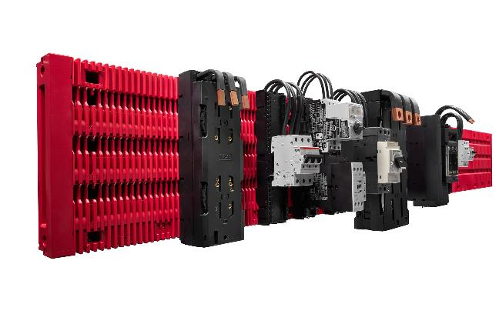

Caption
The RiLineX system now also includes options with a maximum rated current of 550 A. Copper bars of smaller cross-section reduce raw material usage and reduce costs in various applications, including mechanical engineering.

May be reproduced free of charge. Please name Rittal GmbH & Co. KG as the source.

Rittal

Rittal is a leading global supplier of enclosure systems, automation and infrastructure with its industrial, IT, energy and power, cooling and service units. Rittal products and solutions are used in over 90% of global industries – standardised, customised, and always of the very best quality.

Our approach and methodology: Rittal, Rittal Software Systems (Eplan, Cideon) and Rittal Automation Systems (RAS, Ehrt, Alfra) combine their hardware and software expertise to streamline, optimise and industiralise processes across the entire value chain of their customers including their IT infrastructure – from control and switchgear construction, machine building to manufacturing companies or the energy sector.

Our delivery promise: Rittal standard products are delivered in Germany within 24 hours, and within 48 hours throughout Europe.

Customer focus
Improving efficiency and increasing productivity through automation and digitalisation is one of the biggest challenges for our customers. This requires in-depth knowledge and expertise, the combination of hardware and software, and cross-sector networking. We are convinced that creating and connecting data rooms is crucial to the success of industrial transformation. And that is exactly our speciality and field of competence.

Eplan and Rittal are driving the development of the digital automation twin, making data accessible and useable in operations as well. Cideon is improving data consistency in the digital product twin context with its CAD/CAM, PDM/PLM and product configuration expertise.

Sustainability
Environmental and climate protection, social commitment and ethical corporate management are a given for Rittal. We take our responsibility for a sustainable future seriously. Our approach to resource management and conservation involves continuous improvement of our own production processes and ensuring that our products have the lowest possible Product Carbon Footprint. Our solutions support our customers in achieving their own climate targets.
Family business and global player
Founded in 1961, Rittal is the largest company in the owner-operated Friedhelm Loh Group. The group operates worldwide, with more than 12 production sites and over 95 international subsidiaries. It has more than 12,100 employees and posted revenues of 3 billion euros in fiscal 2023. In 2023, the Friedhelm Loh Group was presented with the “Best Place to Learn” and “Employer of the Future” awards. In 2024, Rittal was awarded the Top 100 Seal as one of Germany’s most innovative medium-sized companies for the third time in a row.

For more information, visit www.rittal.com and www.friedhelm-loh-group.com.

Corporate Communications
Dr. Carola Hilbrand Rittal GmbH & Co. KG
Corporate & Brand Communications Auf dem Stützelberg
Phone: +49 (0)2772/ 505- 2527 35745 Herborn, Germany
hilbrand.c@rittal.de www.rittal.com

